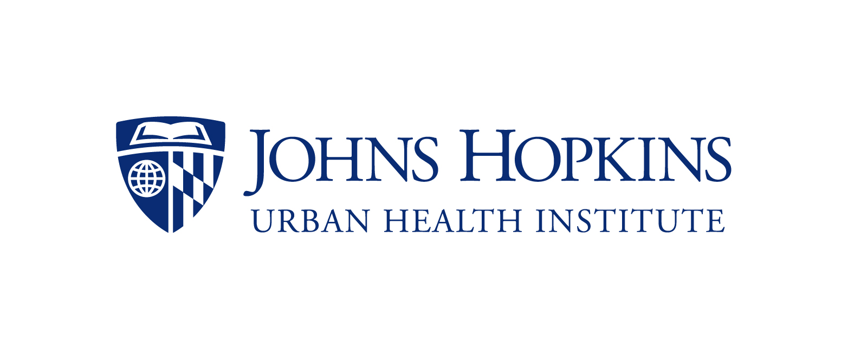

2022 Strategic Consultation Grants for Baltimore City
Cover Page

Title of Project: [Title]
Period of Performance (earliest start date is January 1, 2022): [Start/End Dates]

Requested Budget: [Total Amount]

Baltimore Neighborhood Impact: [Zip code(s) impacted by this project or city-wide]

Is IRB Approval Required? Yes No
If unsure, click here: https://urbanhealth.jhu.edu/_PDFs/human_subjects.pdf

Hopkins Faculty Partner
Faculty Name:
Academic Rank:
School and Department:
Campus Address:
Phone:
JH Email:
JHED ID:

Baltimore City Partner
Name:
Organization:
Address:
Phone:
Email:
Organizational Website, if available:

By signing below, I am verifying that I was involved in the development of this project, have read and approved the final proposal, will remain engaged throughout the course of this project, and will be involved in the preparation and submission of the interim and final reports.

Hopkins Faculty Baltimore City Partner

